**HW #2**

Sai Charan Gunuguntla

Concordia University

Applied Restful APIs&Integrat

Dr. Michael Litman

September 1, 2024

**HW #2**

<https://github.com/search?q=repo%3Ashiva34354%2FHW-2-++language%3AJavaScript&type=code>

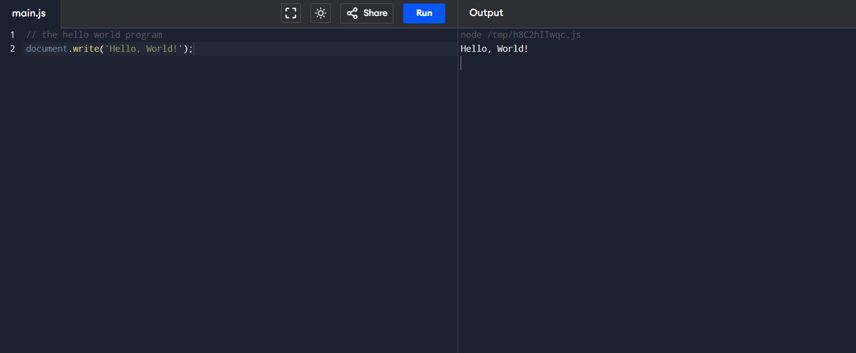

**How long did you spend on this assignment?**

ANS. I have spent 1 hour on this assignment.

**Based on your effort, what letter grade would you say you earned?**

ANS. A grade

**Based on your solution, what letter grade would you say you earned?**

ANS. A grade

**Provide a summary of what doesn't work in your solution and explain how you attempted**

**to solve the problem and where you feel you struggled.**

ANS. There were no hiccups throughout the assignment. I did everything by the instructions and figured it out! The task itself was thrilling, and I had no trouble completing it.